Instructions for Setting Up Patient Portal
Step 1: Check email for Portal Registration Authentication
You should receive an E-mail from RXNT titled, “Welcome To Your Choice MD Health and Wellness Patient Portal”
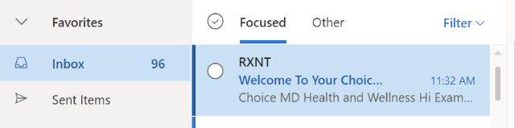
Open the E-mail and click on the button that reads “AUTHENTICATE”
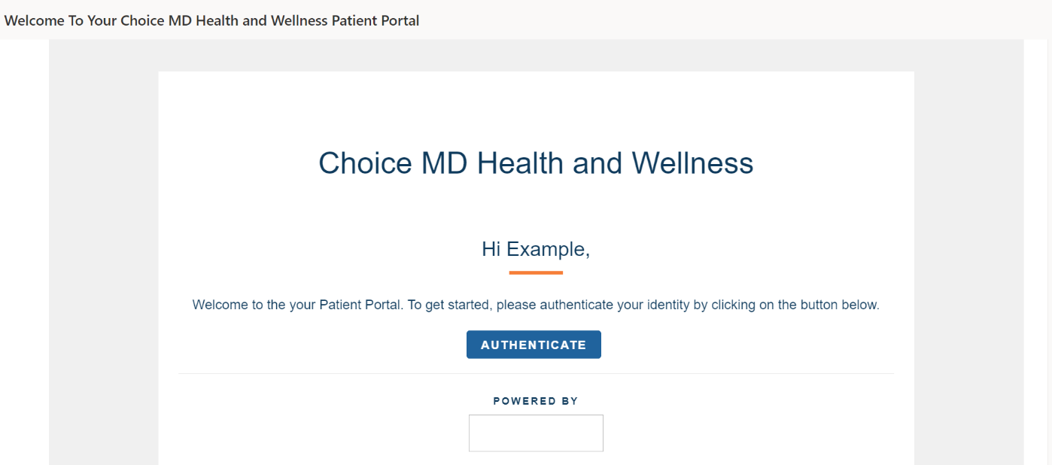
The link will lead you to a page titled, “E-mail Confirmation”, where you must enter your E-mail address, last name, and date of birth to confirm your identity.
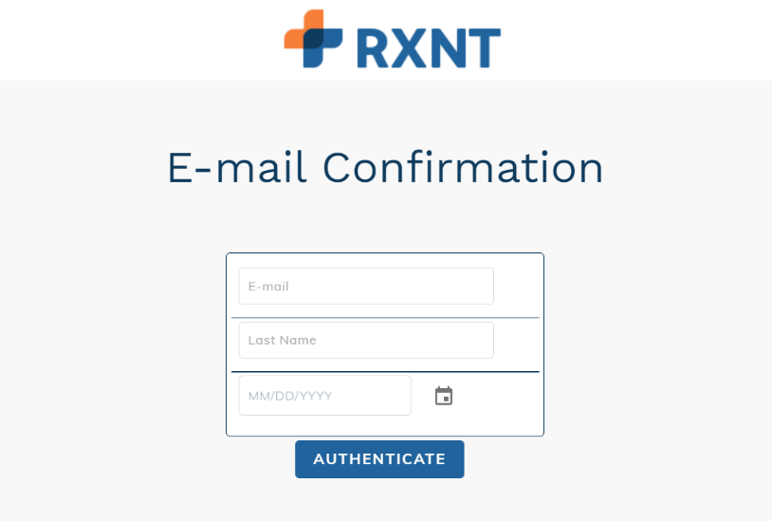

Step 2: Register for Patient Portal with Choice MD Health and Wellness
Upon confirming your identity, you should receive another email from RXNT titled, “Register for Choice MD Health and Wellness Portal”
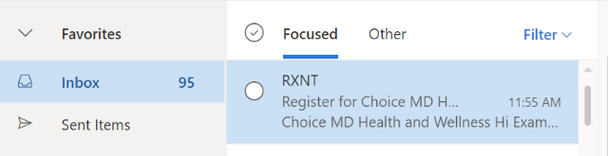
Open the E-mail and you will be led to a page with a registration pin for the patient portal. Click on the button that reads, “REGISTER”.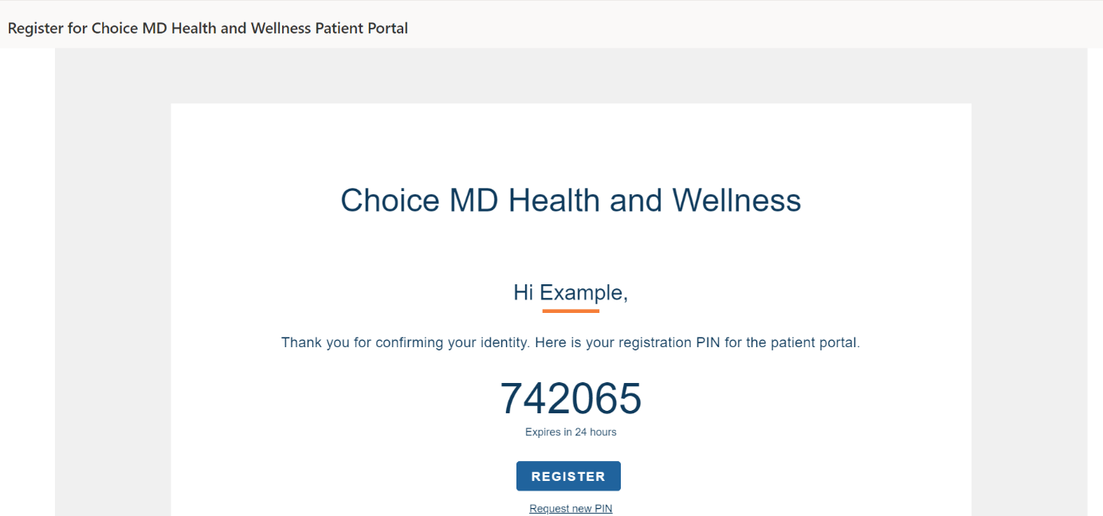
The REGISTER link will lead you to a page where you must enter your first and last name, date of birth, and pin code. When all fields are completed, click next.
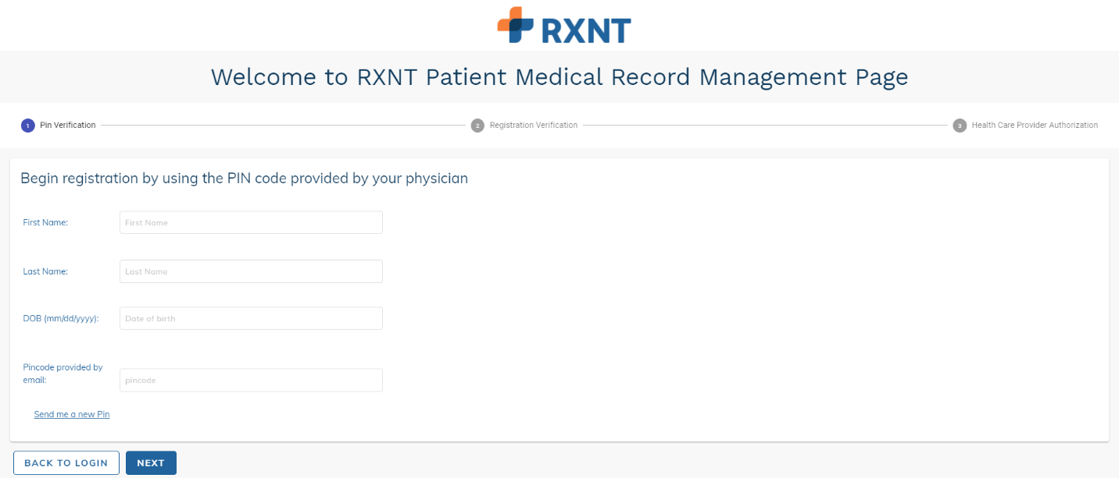

On the next page, you must enter your email and phone number. You will also need to create an email and password to create your patient portal account. We suggest that you use the first letter of your first name and your full last name as your username. Click REGISTER once all fields are completed.
Example: John Smith Username: jsmith
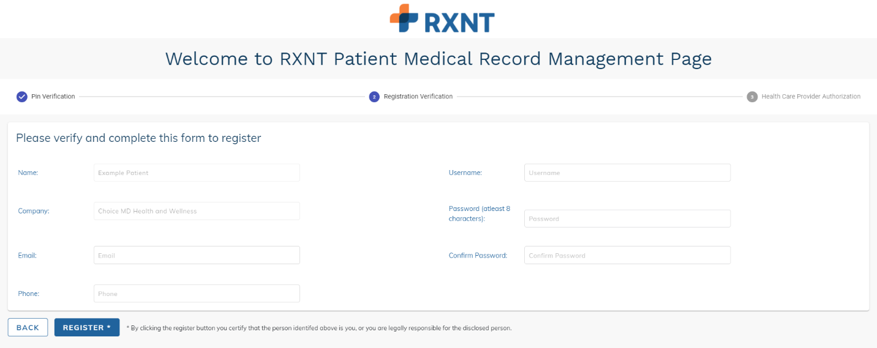

After clicking REGISTER, you will be directed to a different page where you may authorize Choice MD Health and Wellness to release your records through the patient portal. Click ACCEPT once the page is completed.
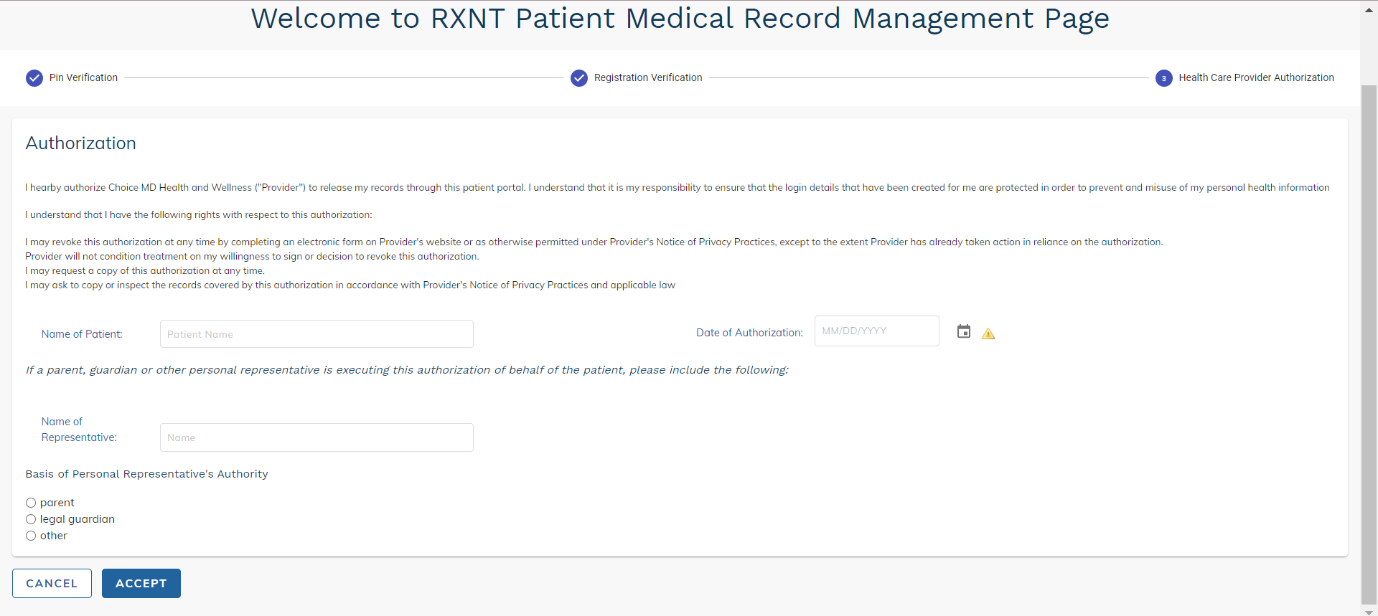

Upon clicking ACCEPT, you will be led to the dashboard of the patient portal. Here, you should fill out any forms under the Action Required box. At the top of the dashboard, you will find tabs to Appointments, Messages, Lab Results, Health Library, Documents, History, Relations and Billing Summary. You will be able to access your patient portal if you remember your username and password to the site.